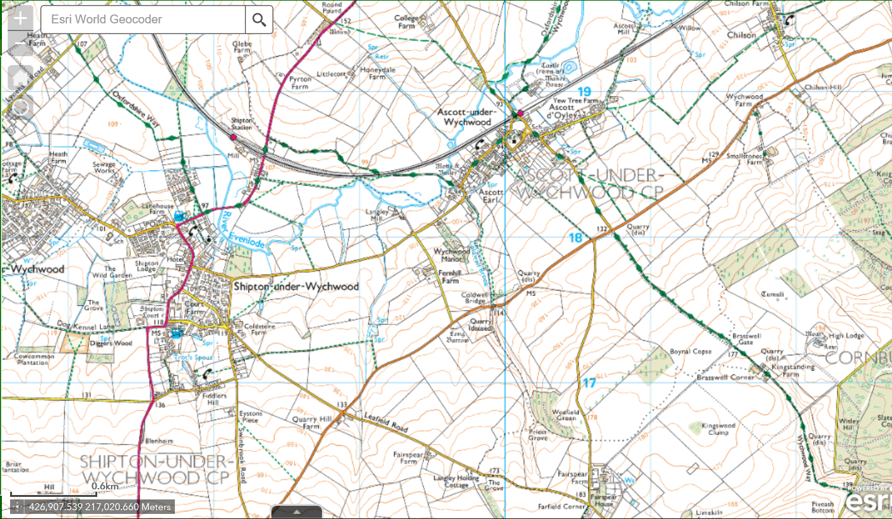

DIVERSION ROUTE

ROAD CLOSURE

ASCOTT UNDER WYCHWOOD – SHIPTON ROAD – MINOR PATCHING